***Introduction to Information Technology – Assessment 2***

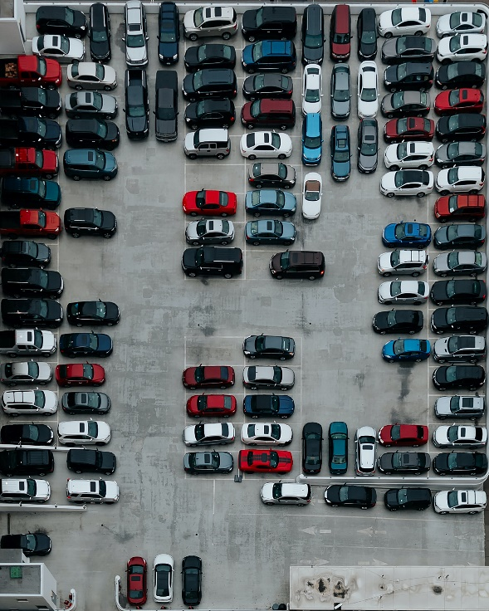***Project Idea –***

As a society, we are constantly developing and growing in many ways. Specifically, our population. With just over 6.680 million people currently residing in Victoria alone, it is no wonder we are such a busy city. Consequently, we face many problems but, one of the most ongoing and ‘annoying’ for most people is parking! Yes, this is a constant hassle, whether it be for a quick trip to pick up groceries or a needed spot to go to university, it is truly a prominent problem that most drivers face. With this in mind, they’re have been ways to counteract this such as increased parking lot sizes or parking time restrictions to limit how long drivers stay there. However, one such way around all of this would be an app that would be able to let you know where parking is available and even the ability to book it!

The inspiration for such an idea was drawn from the fact that our phone is such a powerful tool and provides a plethora of resources at the touch of a few buttons. Especially after the COVID-19 situation, many services, such as food, entertainment, and retail, became more reliant on booking systems as this method is effective and efficient regarding customer wants and needs Now there are apps present that have such functions, but none have truly accomplished this as most can agree. For example, whenever you enter a large shopping complex and try to find parking, you will notice the overhead indicator sensors well indicate whether a parking spot is free. For some reason though, you get there and to your surprise, there is a vehicle parked in there! It can be frustrating and hence, having the ability to have an app that can indicate truly whether a parking spot is free or not will be revolutionary as it reduces the opportunity for road rage, congestion in parking lots and most of all, provides a fast and efficient service for users. This is because the improved system will mean that drivers will be more organised when it comes to their travel plans as they now possess, at their convenience, the ability to observe and make bookings for a parking system. As such, the stress factors of finding parking for motorists, law enforcers and councils are alleviated due to more parking spots being readily available for users.

The design of this app will have the purpose in mind to reduce the problematic impact of the current parking situation. The application will have the ability to indicate parking lots nearby that have parking spaces available. Accomplishing this will require the user to indicate whereabouts they are located as the app will be able to allocate the nearest parking to your destination. This system will then need to be linked to the already vehicle detection sensors that are present in most shopping complexes. As discussed, the overhead sensors present issues with indicating whether a vehicle is truly parked or not. So, to overcome this, the addition of two implementations can be made. The first being the booking system. This may be done through the app and will indicate what spots are available on which levels. To compliment this, it would be recommended for the use of in-ground parking sensors as from experience, these provide a more accurate reading. The in-ground sensors being reliable as well, also have the function to alert parking officers that vehicles have illegally parked in a booked spot or overstayed their booked duration. The app would then be able to display that which spots can be booked for parking and the user will then be able to have the ability to book using the app if they wish to guarantee the user that spot. As most users are used to online purchasing, this will be a similar process and allow the user to input such details and the spot will be reserved. Furthermore, if the parking area has set rules, such as parking time limits or payment to use parking, the system online will be able to provide these details and inform users if a pre-payment needs to be made to secure your spot. To indicate whether a spot is reserved or not, the use of the overhead sensors may display a red light indicating the spot has been reserved. Now depending on the budget of this project, problems may arise. For instance, having a spot indicate whether it’s been booked or not is well and all, but some people may still decide to park. This can be frustrating as the system does rely on cooperation from drivers. The alternate solutions, which require more funding, but will ultimately ensure this is not a problem would be to have an employee place a bollard/barricade in the spot once it has booked. The user can then alert the attendee that they have arrived for their parking and this can be removed. Alternatively, to reduce the manual labour needed, having an in-ground retractable bollard in the centre or front of the parking can extend once the booking has been made. Again, once a driver has arrived, they simply need to use their app to send an alert that they have arrived for the bollard to retract. Similarly, another big issue to ensure this app is successful will be the implementation of the sensory technology. It will be a big cost but will be worth the while as it ensures drivers can now have a secured spot instead of the mad scramble most of us experience. On the other hand, even though this system would be implemented into parking located in shopping centres, congested areas, and more, it may be unrealistic and unwise to have every parking complex have this sensory system in place as it requires more funding for the setting up, managing and maintenance of the systems. To overcome this, the parking ticket machines that are present in most parking areas can have a similar system be implemented and be used to select a parking spot. A driver would be then able to go to the designated parking spot they choose. This information can then be relayed to the app and it can indicate which parking lots have parking available. In totality, this will also eliminate the problem for those drivers who do not want to book and would rather just turn up to the centre and hope for a parking spot 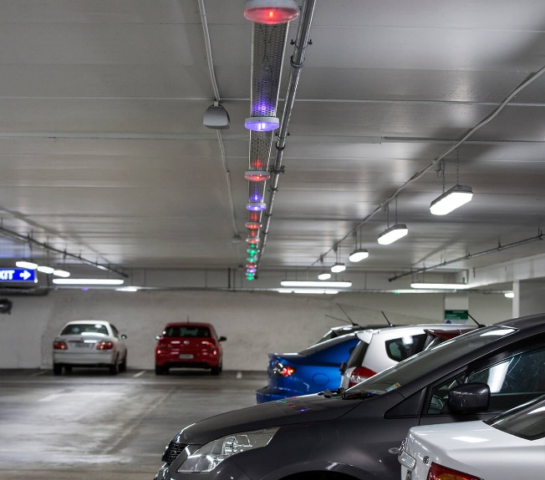available. And like any application, the project will need to go through several phases of testing. This will need to be done in both the website/application and the technology. The testing for the website/application will be to ensure that the system is easy for users to navigate and use and for their experience of booking to not be limited by the website. The link between the sensory system and the booking system will then be tested once established. This may include making sure the website is not static and provide live updates for each parking lot. By having the app update the status of a parking spot as a user is booking/has booked, this will reduce the confusion when it comes to using the website/application. As mentioned previously, it will require a huge effort to get this project underway but a recommendation for the testing process could be simply a singular parking spot with all the sensory set up for it or a miniature version of it. This will verify and solidify the feasibility of the project. Both the parking spot and miniature would need to make certain of the following points:

* Whether the booking app/website functions as intended – the user will be informed of the available spots, what the conditions to book the spots, details of the parking shop and more and hence, they would be able to book/pay for the spot (if required) and will display as being booked or booked to other users
* The booking system is linked to sensory system properly – this will be indicated by whether the bollard or barricade has been put in place once a booking has occurred.
* The sensory system and its reliability – making certain that the in-ground sensors detect different vehicles and that this will also update the overhead sensors to display to users that the spot is in use/been booked.

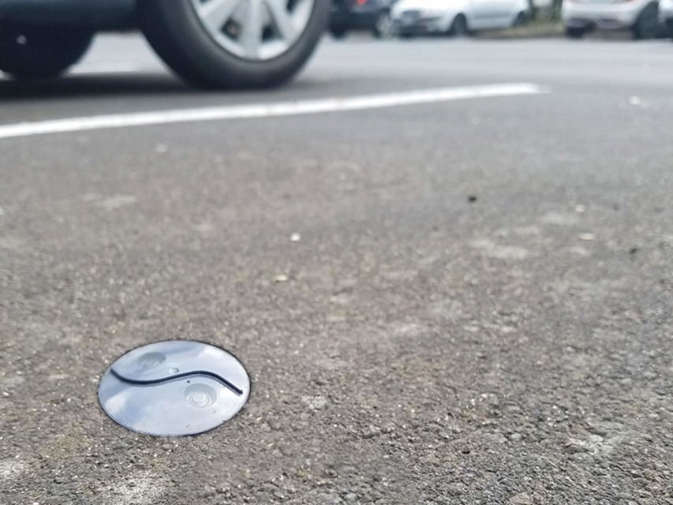For this idea to launch, it will require the use of the app to be created and have such functions as mentioned previously. This app can be available across all devices, being tablet, phone, and computer friendly. Likewise, the system may also be on a website as well for more casual users and ensures the system appeals to both casual and regular parking bookers. The other piece of hardware needed, which is dependent on budget, would be the installation of the in-ground sensors for the parking and the method to stop those parking in reserved spots; either a manual process of an attendee employed for such or an in-ground retractable bollard. Furthermore, the app would then need to have access and linked to the parking companies’ systems and sensory technology within as this will allow for the communication and relay of information of whether parking is available, the ability to see whether a user can book or not, and more. It’s not a far stretch but certainly does require a lot of cooperation between the parking companies and the developer of the app/website.

Consequently, this will be a demanding project and having great time management, persistence and a solution-oriented mindset is the best approach to undertake such a project. To hit the ground running with this project, being able to use a mobile app development software and website creation is necessary. Having experience and skills in software’s such as Appy Pie or BuildFire will allow the project to be carried out smoothly as the parking system requires minimal coding ability to create the beginnings of a well thought out application. Despite these ‘requirements’, such skills and software are in reasonable reach as they are skills we develop in everyday life and work. The workflow would be most impeded by the need for access to parking databases and information as this will need to be negotiated. However, after the details have been sorted, the app/website booking system would need to link to the sensors.

All in all, developing a parking app will surely ease the current problem of finding parking and the congestion it creates in a fair and equitable manner. Parties such as motorists, law enforcers, councils and management teams will all be impacted in a pleasant way as it reduces the burdens parking creates for them. The apps interface and functions will allow for a smoother process of finding a parking that is suitable and available for all drivers, rather than hoping for the best. The use of essentially a booking system and parking indicator system will allow for a more relax environment when it comes to parking. This in turn will reduce the road rage and competition for a parking spot and instead, make this process an efficient and civil viability for those who choose to use this app/website.